Chapter 15, Solution 30.

(a) 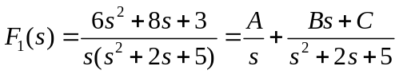

We equate coefficients.
s² : 6 = A + B
s: 8= 2A + C
constant: 3=5A or A=3/5
B=6-A = 27/5, C=8-2A = 34/5

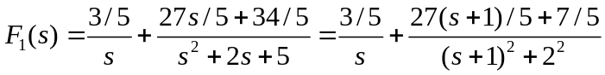

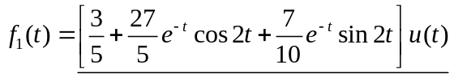

(b) 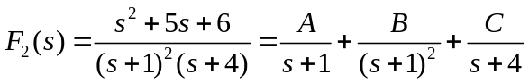
Equating coefficients,

s² : 1=A+C
s: 5=5A+B+2C
constant: 6=4A+4B+C
Solving these gives
A=7/9, B= 2/3, C=2/9

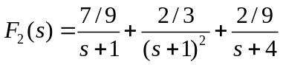

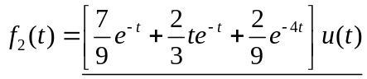

(c ) 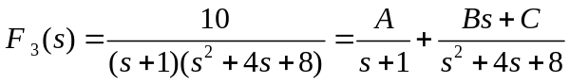
s² : 0 = A + B or B = -A
s: 0=4A+ B + C
constant: 10=8A+C
Solving these yields
A=2, B= -2, C= -6
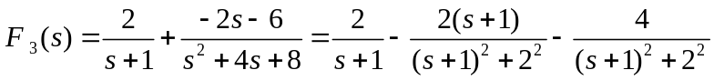

f₃(t) = (2e^{–t} – 2e^{–t}cos(2t) – 2e^{–t}sin(2t))u(t).

